Spring:

**Java Database Connectivity (JDBC):**

* RDBMS understand SQL language only.
* JDBC driver converts Java requests in database understandable form and database response in Java understandable form.
* JDBC drivers are of 4 types
* Type I - Jdbc Odbc Bridge driver:
* ODBC is standard of connecting to RDBMS (by Microsoft).
* Needs to create a DSN (data source name) from the control panel.
* From Java application JDBC Type I driver can communicate with that ODBC driver (DSN).
* The driver class: sun.jdbc.odbc.JdbcOdbcDriver -- built-in in Java.
* database url: jdbc:odbc:dsn
* Advantages: Can be easily connected to any database.
* Disadvantages: Slower execution (Multiple layers). The ODBC driver needs to be installed on the client machine.
* Type II - Partial Java/Native driver:
* Partially implemented in Java and partially in C/C++. Java code calls C/C++ methods via JNI.
* Different driver for different RDBMS. Example: Oracle OCI driver.
* Advantages: Faster execution
* Disadvantages: Partially in Java (not truly portable) Different driver for Different RDBMS
* Type III - Middleware/Network driver:
* Driver communicates with a middleware that in turn talks to RDBMS.
* Example: WebLogic RMI Driver
* Advantages: Client coding is easier (most task done by middleware)
* Disadvantages: Maintaining middleware is costlier. Middleware specific to database
* Type IV:
* Database specific driver written completely in Java.
* Fully portable.
* Most commonly used.
* Example: Oracle thin driver, MySQL Connector/J, ...

MySQL Programming Steps:

* step 0: Add JDBC driver into project/classpath.
  + Project Properties -> Java Build Path -> Libraries - Classpath -> Add External Jas -> select mysql driver jar -> Ok
* step 1: Load and register JDBC driver class. These drivers are auto-registered when loaded first time in JVM. This step is optional in Java SE applications from JDBC 4 spec.

//Class.forName("com.mysql.cj.jdbc.Driver");

* step 2: Create JDBC connection using helper class DriverManager.

//Connection con = DriverManager.getConnection("jdbc:mysql://localhost:3306/dbname", "root", "manager");

* step 3: Create the statement.

//Statement stmt = con.createStatement();

* step 4: Execute the SQL query using the statement and process the result.

1.// String sql = "select query";

ResultSet rs = stmt.executeQuery(sql);

2.// String sql = "non-select query";

int count = stmt.executeUpdate(sql);

* step 5: Close statement and connection.

//stmt.close();

con.close();

**DAO class:**

* In enterprise applications, there are multiple tables and frequent data transfer from database is needed.
* Instead of writing a JDBC code in multiple Java files of the application (as and when needed), it is good practice to keep all the JDBC code in a centralized place -- in a single application layer.
* DAO (Data Access Object) class is standard way to implement all CRUD operations specific to a table. It is advised to create different DAO for different table.
* DAO classes make application more readable/maintainable.

**Transaction Management:** Transaction is set of DML operations to be executed as a single unit. Either all queries in tx should be successful or all should be discarded. The transactions must be atomic. They should never be partial.

**Result Set:**

**Result Set types: -**

* TYPE_FORWARD_ONLY -- default type
  + next () -- fetch the next row from the db. and return true. If no row is available, return false.
* TYPE_SCROLL_INSENSITIVE
  + next() -- fetch the next row from the db and return true. If no row is available, return false.
  + previous() -- fetch the previous row from the db and return true. If no row is available, return false.
  + absolute(rownum) -- fetch the row with given row number and return true. If no row is available (of that number), return false.
  + relative(rownum) -- fetch the row of next rownum from current position and return true. If no row is available (of that number), return false.
  + first(), last() -- fetch the first/last row from db.
  + beforeFirst(), afterLast() -- set ResultSet to respective positions.
  + INSENSITIVE -- After taking ResultSet if any changes are done in database, those will NOT be available/accessible using ResultSet object. Such ResultSet is INSENSITIVE to the changes (done externally).
* TYPE_SCROLL_SENSITIVE
  + SCROLL -- same as above.
  + SENSITIVE -- After taking ResultSet if any changes are done in database, those will be available/accessible using ResultSet object. Such ResultSet is SENSITIVE to the changes (done externally).

**Result Set concurrency: -**

* CONCUR_READ_ONLY -- Using this ResultSet one can only read from db (not DML operations). This is default concurrency.
* CONCUR_UPDATABLE -- Using this ResultSet one can read from db as well as perform INSERT, UPDATE and DELETE operations on database.

**Maven:**

* Maven is Java Build Tool.
* pom.xml:
  + - pom.xml is heart of Maven.
    - POM - Project Object Model.
    - It is located into root of Maven project.
    - pom.xml holds build details of the project 🡺 profiles dependencies build plugins

dependencies:

Third-party jars to be added into the project.

Dependency is uniquely identified by the groupId, artifactId and version.

All jars auto-downloaded from Maven repository and added into project CLASSPATH.

Profiles:

Maven enable building projects in different configurations like dev, test, production, etc.

It enables doing changes in build steps/config for certain profile.

build plugins:

Allows to add user-defined actions in the build process.

Implemented by frameworks for customization in build process.

Build phases:

A build life cycle is divided into sequence of multiple build phases.

Important build phases in default build life cycle.

* + - validate: Check project pom.xml syntax. Downloads all dependencies (if not present in local repository).
    - compile: Compile source code of the project.
    - test: Execute given unit tests against the compiled source code using a suitable unit testing framework.
    - package: Pack the generated files into given package (jar or war).
    - install: Copy the package into the local repository. It can be used in other projects on local machine.
    - deploy: Copy the final package to the remote repository for sharing with other developers and projects.

=================================================================================================================

**Spring:**

**-** Initially developed by "Rod Johnson" in 2003.

- Early versions of spring were relying on XML config (till Java 1.4).

-Later versions (3.0+) added support of annotation config (from Java 5.0+).

-Spring 3.0 became popular spring version.

Spring is lightweight comprehensive framework that simplifies Java development. "light-weight" - basic version of Spring framework is around 2 MB. "comprehensive" - dependency injection "Simplifies Java development" - Ready-made support/wrappers for different Java technologies, Unit testing, ... Inversion of Control - Dependency injection.

**JDBC:**

Load & register class (managed by spring)

Create connection (managed by spring)

Create statement (managed by spring)

Execute the query (managed by spring)

Process the result (ResultSet) -- supply SQL statement, parameters and process result.

Close all (managed by spring)

**Hibernate**

Hibernate configuration (.cfg.xml or coding) (managed by spring)

Create SessionFactory (managed by spring)

Create session (managed by spring)

transaction management (managed by spring)

CRUD operations or Query execution -- user-defined

Cleanup (managed by spring)

* Unified transaction management (local & distributed/global) -- @Transactional Local transactions:

Within same database Global transactions - JTA: Across the databases

* Easier Java EE development through Spring Web MVC (Pull) and Web sockets (Push).
* Consistent and "readable" unchecked exceptions - wraps technology-specific exceptions.

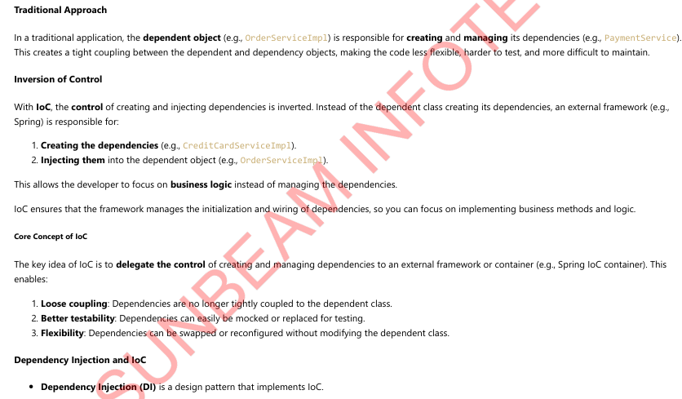

**Spring Beans:**

Spring beans are Java class objects instantiated by Spring container.

Beans are created and initialized as per user-defined configuration (bean definition).

Spring bean classes are simple Java POJO classes with one or more business logic method.

Application Context:

* Spring container is created while ApplicationContext is created.
* ApplicationContext enable accessing Spring container features in the application.
* ApplicationContext is an interface and have various implementations for different scenarios/applications.
* ApplicationContext
* ClassPathXmlApplicationContext
* ClassPathXmlApplicationContext ctx = new ClassPathXmlApplicationContext("beans.xml"); // beans.xml in resources or src dir.
* FileSystemXmlApplicationContext
* FileSystemXmlApplicationContext ctx = new FileSystemXmlApplicationContext("/home/nilesh/beans.xml"); // beans.xml is in some folder.
* AnnotationConfigApplicationContext
* AnnotationConfigApplicationContext ctx = new AnnotationConfigApplicationContext(AppConfig.class); // AppConfig is @Configuration class
* WebApplicationContext (interface)
* XmlWebApplicationContext
* AnnotationConfigWebApplicationContext
* ApplicationContext (Spring Container) create all (singleton) beans when application context is loaded.
* ApplicationContext interface itself is inherited from BeanFactory interface.
* It provides basic facility of Beans loading and initialization.
* Typical spring applications have single ApplicationContext.

Dependency Resolution Process:

* The ApplicationContext is created and initialized with configuration metadata (XML or annotations) that describes all the beans.
* For each bean, its dependencies are expressed in the form of properties or constructor arguments. These dependencies are injected when the bean is actually created.
* Each property or constructor argument can be a value (primitive type) or reference of another spring bean.
* The value is converted from its specified format to the actual type of that property or constructor argument.

**Spring Boot:**

Spring Boot is a Framework from "The Spring Team" to ease the bootstrapping and development of new Spring Applications.

* Framework (Not a completely new framework -- rather it is abstraction on existing spring frameworks)
* Ease bootstrapping - Quick Start (Rapid Application Development)
* New applications - Not good choice for legacy applications

Abstraction/integration/simplification over existing spring framework/modules.

* Spring core
* Spring Web MVC
* Spring Security
* Spring ORM

NOT replacement or performance improvement of Spring framework Not replacement, but it is abstraction.

Underlying same Spring framework is working -- with same speed.

Spring Boot = Spring framework + Embedded web-server + Auto-configuration - XML configuration - Jar conflicts.

Why Spring Boot:

Provide a radically faster and widely accessible "Quick Start". Very easy to develop production grade applications. Reduce development time drastically. Increase productivity. Spring Boot CLI Spring Initializer (https://start.spring.io/) IDE support - Eclipse based Spring Tools IDE (STS) Build tools - Maven/Gradle support.

Managing versions of dependencies with starter projects:

Set of convenient dependency descriptors

Hierarchically arranged so that minimal dependencies to be added in application

e.g. spring-boot-starter-web

* spring-web
* spring-webmvc
* spring-boot-starter
  + spring-core
  + spring-context
  + spring-boot-autoconfigure
  + spring-boot-starter-logging

log4j-to-slf4j

jul-to-slf4j

spring-boot-starter-json

jackson-databind

spring-boot-starter-tomcat

tomcat-embed-core

tomcat-embed-websocket

jakarta.el

hibernate-validator

No extra code generation (boiler-plate is pre-implemented) and No XML config.

Minimal configuration required.

Ready to use in-memory/embedded databases, ORM/JPA, MVC/REST, ...

Opinionated configuration, yet quickly modifiable for different requirements.

Easy/quick integration with standard technologies/frameworks.

Examples:

Web applications – Tomcat

ORM -- Hibernate

JSON -- Jackson

Test – Junit

You can change the configuration/technologies by adding alternates on pom.xml (classpath). Provide lot of non-functional common features (e.g. security, servers, health checks, ...). Easy deployment and Containerisation. Embedded Web Server for web applications.

* @SpringBootApplication = @ComponentScan + @Configuration + @EnableAutoConfiguration
* @ComponentScan
* Auto detection of spring stereo-type annotated beans e.g. @Component, @Service, @Repository, @Configuration, @Controller, @RestController, ...
* By default, basePackage is to search into current package (and its sub-packages).
* @ComponentScan ("other. package") can be added explicitly to search of beans/config into given package.
* @Configuration
* Spring annotation configuration to create beans.
* Contains @Bean methods which create and return beans.
* @Configuration classes are also auto-detected by @ComponentScan
* @EnableAutoConfiguration annotation
* Intelligent and automatic configuration.
* Auto-configuration class are internally Spring @Configuration classes.
* @Conditional beans:
* @ConditionalOnClass
* @ConditionalOnMissingBean

**Spring Bean Life Cycle**

* Life cycle of a java object is governed by the container that creates the object.
* Container do call certain methods the object to initialize it or give some information.
* Java applets are executed by JRE plugin in the browser (referred as applet container). It used to call methods of applet.
* init(), start (), paint (), stop (), destroy ().
* Java servlets are executed by web container in the Java web server. It calls the certain methods of the servlet object.
* init(), service (), destroy ()
* The life cycle methods are callback methods i.e. they are implemented by the programmer and are invoked by the container.
* init() method is called by the container and all container services are accessible from there. This is not possible while construction of the object.

**Explanation:**

* If @Configuration classes are in same package they are auto-detected due to @SpringBootApplication (@ComponentScan).
* All @Bean are by default singleton beans and hence created as soon as ApplicationContext is created (by SpringApplication.run()).
* ApplicationContext can be accessed in any Spring bean using ApplicationContextAware interface.
* ApplicationContext is used to access the beans using ctx.getBean() method.
* Spring bean provides various callback interfaces.

Reference: https://docs.spring.io/spring-framework/docs/current/reference/html/core.html#beans-factory-lifecycle

* Possible bean initialization callbacks

InitializingBean interface is legacy way of Spring bean initialization callback. Not recommended in modern applications.

XML configuration relies on <bean ... init-method="initMethodName"/>.

Annotation config usually follows JSR-250 annotation @PostConstruct.

BeanPostProcessor:

* To perform certain actions on mutliple beans initialization, custom BeanPostProcessor is used.
* There are multiple pre-defined BeanPostProcessor.

AutowiredAnnotationBeanPostProcessor

InitDestroyAnnotationBeanPostProcessor

BeanValidationPostProcessor

Bean creation: 1. Constructor

2. Fields/setters initialized (DI)

3. BeanNameAware.setBeanName()

4. ApplicationContextAware.setApplicationContext()

5. CustomBeanPostProcessor.postProcessBeforeInitialization()

6. @PostConstruct method invoked

7. InitializingBean.afterPropertiesSet()

8. CustomBeanPostProcessor.postProcessAfterInitialization()

9. Bean is ready to use

Bean destruction: 1. @PreDestroy method invoked

2. DisposableBean.destroy()

3. Object.finalize()

4. Bean will be garbage collected

**Stereo-type annotations:**

* Spring container can auto-detect certain beans (without defining as @Bean method or XML config). It also manages their bean life cycle.
* Following annotations are auto-detected by Spring container using @ComponentScan.
* @Component -- general-purpose (no special significance) spring bean.
* @Service-- Spring beans containing business logic
* @Repository-- Spring beans handling data/database connectivity
* @Controller-- Spring beans handling navigation, user-interaction in Spring web-mvc applications.
* @RestController -- It is @Controller used for REST services.
* @Configuration -- To be used for spring annotation config (not to be used as spring bean).
* Stereo-type annotations are always written at class level.
* Using @ComponentScan, all classes with above annotations in given package and its sub-packages will be instatiated as Spring beans.
* If no package is given, all classes in current package will be scanned for stereo-type annotations.
* This behaviour can be customized using includeFilters and/or excludeFilters.
* XML configuration equivalent of @ComponentScan <context:component-scan>.

**Auto-wiring:**

* Auto-detection of dependencies and injecting them into dependent objects is also referred as "Autowiring".
* Auto-wiring can be done in XML config using <bean id="..." class=”…”autowire="default|no|byType|byName|constructor" .../>.
* default/no = By default auto-wiring is disabled.
* byType = auto wire(connect) the bean with matching type (when single bean of matching type is available).
* byName = auto wire(connect) the bean with matching name.
* constructor = auto wire(connect) the bean into constructor of dependent bean.

Auto-wiring is done into Java config using spring annotation @Autowired.

@Autowired can be used at

Setter level: setter-based DI

Constructor level: constructor-based DI

Field level: field-based DI

Constructor based @Autowired DI is preferred over Setter based DI & Field based DI.

From Spring 5, single argument constructors have @Autowired implicitly.

@Autowired resolution process:

* @Autowired finds bean of corresponding field "type" and assign it.
* If no bean is found of given type, it throws exception.
* @Autowired(required=false): no exception is thrown, auto-wiring skipped.
* If multiple beans are found of given type, it try to attach bean of same name. If no such bean is found,
* then throw exception.
* If multiple beans are found of given type, programmer can use @Qualifier to choose expected bean.
* @Qualifier can only be used to resolve conflict in case of @Autowired.
* If multiple beans are found of given type, one of the bean can be declared as @Primary. If no
* @Qualifier is mentioned, then @Primary bean will be attached (and no exception is produced).
* @Autowired --> byType, byQualifier (@Qualifier), byName.
* @Resource resolution: DI byName, byType, byQualifier.

**Spring Bean Scopes:**

* Using a bean definition (@Bean or Stereo-type annotations + Other config), one or more bean objects can be created.
* The bean scope can be set in XML or annotation.

<bean id="___" class="___" scope="singleton|prototype|request|session" />

@Scope("singleton|prototype|request|session") on @Bean / @Component ...

* Spring 5 supports six different bean scopes. Four scopes are valid only if you use a web-aware ApplicationContext.

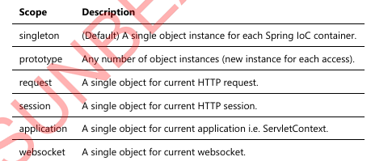

Singleton:

* Single bean object is created and accessed throughout the application.
* BeanFactory creates object when getBean() is called for first time for that bean.
* All singleton bean objects are created when ApplicationContext is created.
* For each sub-sequent call to getBean() returns same object reference.
* Reference of all singleton beans is managed by spring container.
* During shutdown, all singleton beans are destroyed (@PreDestroy will be called).

Prototype:

* No bean is created during startup.
* Reference of bean is not maintained by ApplicationContext.
* Beans are not destroyed automatically during shutdown.
* Bean object is created each time ctx.getBean() is called.

**HTTP protocol:**

* HTTP -- Hyper Text Transfer Protocol.
* Connection-less protocol.
* State-less protocol.
* Request-response model.
* Web server is program that enable loading multiple web applications in it.
* Web application is set of web pages (static or dynamic), which are served over HTTP protocol.
* Client makes request by entering URL, click submit, or click hyper link.
* URL: <http://server:port/appln/resource>:
* http: protocol/scheme
* server: machine name or IP address
* port: default 80
* URI: /appln/resource
* Request Headers:
* Server/Host: server name/ip + port
* User-Agent: Browser type/version
* URI
* HTTP version: 1.0 or 1.1
* Content-Type: Type of data in Request body -- application/json, text/...
* Length: Number of bytes in Request body

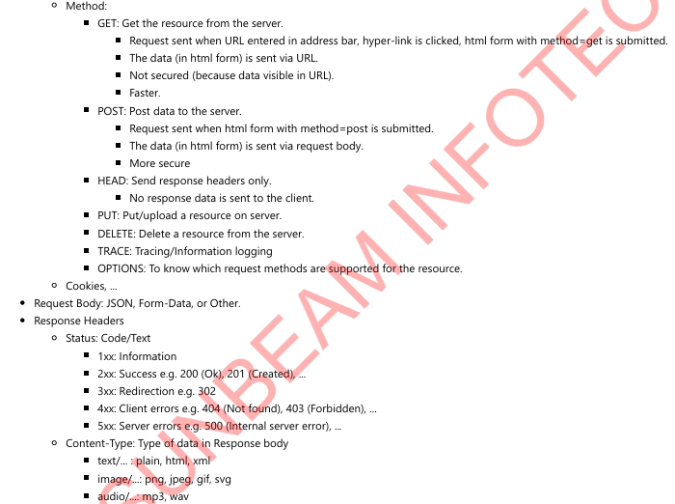

**Spring Web MVC:**

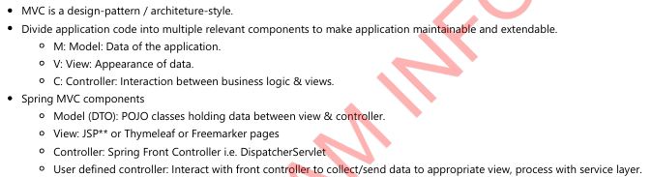

**Spring Web MVC Flow:**

* DispatcherServlet receives the request.
* DispatcherServlet dispatches the task of selecting an appropriate controller to HandlerMapping. HandlerMapping selects the controller which is mapped to
* the incoming request URL and returns the (selected Handler) and Controller to DispatcherServlet.
* DispatcherServlet dispatches the task of executing of business logic of Controller to HandlerAdapter.
* HandlerAdapter calls the request handler method of @Controller.
* Controller executes the business logic, sets the processing result in Model and returns the logical name of view to HandlerAdapter.
* DispatcherServlet dispatches the task of resolving the View corresponding to the View name to ViewResolver. ViewResolver returns the View Path mapped to
* View name.
* DispatcherServlet dispatches the rendering process to View class / View Engine.
* It renders view with Model data and returns the response.

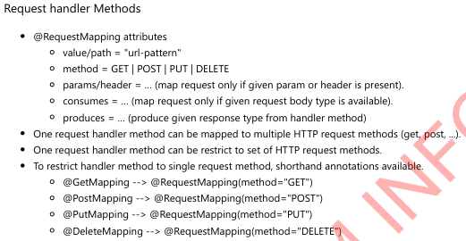

**REST web services: REST stands for Representational State Transfer.**

* Object characteristics: State, Behaviour & Identity.
* State: Values of data members/fields.
* Object state can be transferred (from server to client & vice-versa) in any format like JSON or XML.
* It is a Protocol to invoke web services from any client (with internet connection).
* Client can use any platform/language.
* REST is lightweight (than SOAP).
  + No stub and proxy classes.
  + No XML grammer (xsd) checks.
* REST works on top of HTTP protocol.
* It uses HTTP protocol request methods.
* GET: to get records.
* POST: to create new record.
* PUT: to update existing record.
* DELETE: to delete record.
* REST services are stateless:
* Each REST request is independent of another.
* Request should include all required inputs and produce expected output.

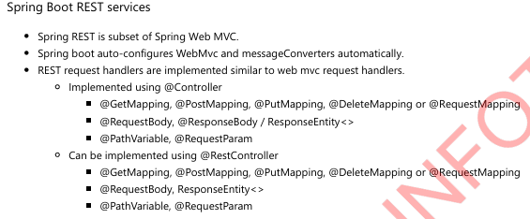

**Response Entity: Response Entity object is used to control response status as well as response body.**

**If ResponseEntity<> is return type, no need to use @ResponseBody explicitly.**

**Important methods:**

ResponseEntity.ok(body) --> ResponseEntity object

status = 200

body = given object json representation

ResponseEntity.notFound() --> HeaderBuilders object (not to be returned from method)

status = 404

ResponseEntity.notFound().build() --> ResponseEntity object

status = 404

body = empty response body

ResponseEntity.notFound().body(obj) --> ResponseEntity object

status = 404

body = given object json representation

ResponseEntity.noContent() --> HeaderBuilders object (not to be returned from method)

status = 204

ResponseEntity.noContent().build() --> ResponseEntity object

status = 204

body = empty response body

ResponseEntity.noContent().body(obj) --> ResponseEntity object

status = 204

body = given object json representation

ResponseEntity.created(uri) --> BodyBuilder object (not to be returned from method)

status = 201

ResponseEntity.created(uri).build() --> ResponseEntity object

status = 201

body = empty response body

ResponseEntity.created(uri).body(obj) --> ResponseEntity object

status = 201

body = given object json representation

ResponseEntity.internalServerError() --> HeaderBuilders object (not to be returned from method)

status = 500

ResponseEntity.internalServerError().build() --> ResponseEntity object

status = 500

body = empty response body

ResponseEntity.internalServerError(). body(obj) --> ResponseEntity object

status = 500

body = given object json representation

ResponseEntity.status(code) --> BodyBuilder object (not to be returned from method)

status = given code

ResponseEntity.status(code). body(obj) --> ResponseEntity object

status = given code

body = given object json representation

***Spring REST Internals:***

* Spring REST is subset of Spring MVC.
* Like Spring MVC
* Each request first encountered by Front controller.
* The request url is mapped to Request handler method (in controller) by HandlerMapping bean.
* This request handler method is executed by HandlerAdapter bean.
* To deal with @RequestBody and @ResponseBody, handler-adapter bean creates RequestResponseBodyMethodProcessor bean.
* This bean internally uses Jackson converter (MappingJackson2HttpMessageConverter bean) to convert request body json to required Java object (as given in
* method argument).
* Then request handler method is executed that may call service and dao layer. It produces response Java object.
* Again, RequestResponseBodyMethodProcessor bean internally use Jackson converter to convert Java object to Json format.
* Finally, this Json response is sent back to the client by DispatcherServlet.

Content Negotiation:

* Server is capable of producing/consuming different data formats e.g. JSON, XML, ...
* Client can get any format in which it is interested.
* Spring REST application can support multiple formats by multiple message converters. Example:
* MappingJackson2HttpMessageConverter -- JSON format
* MappingJackson2XmlHttpMessageConverter -- XML format
* Spring Boot will auto-create these message converters if respective dependencies are added in project. Spring will also auto add these converters into the list of converters used RequestResponseBodyMethodProcessor.
* Maven jackson-databind -- auto create -- MappingJackson2HttpMessageConverter
* Maven jackson-dataformat-xml -- auto create MappingJackson2XmlHttpMessageConverter
* Client application/Postman can now request REST API with request header "Accept"="application/json" to get the Json response and "Accept"="text/xml" to get XML response. The default is "Json".
* It is possible that server may produce only XML or only Json result.

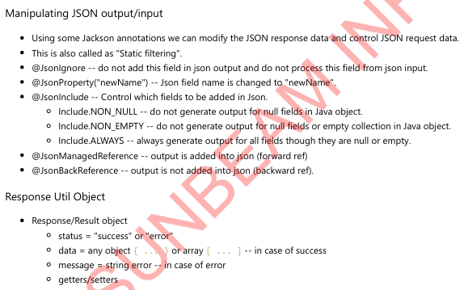

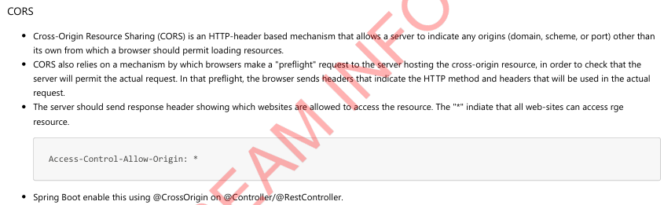

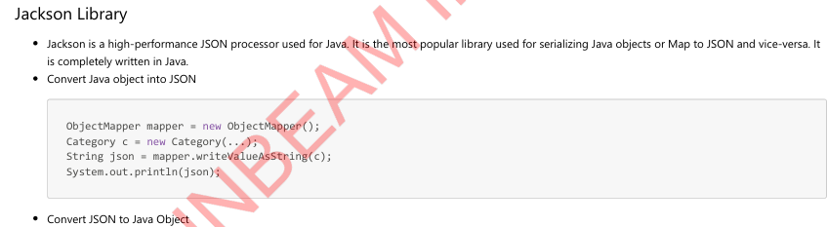

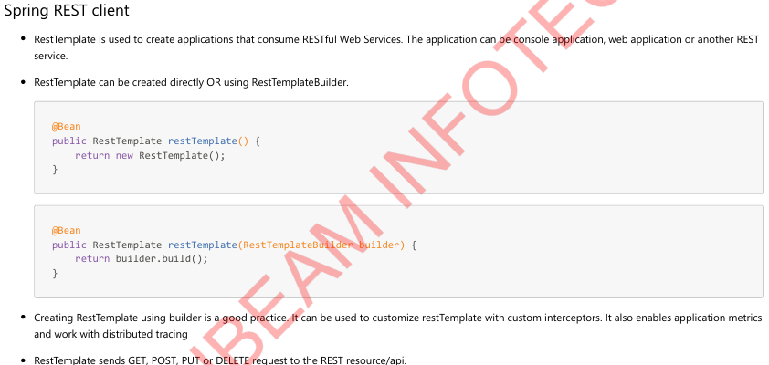

UriComponentsBuilder can be used to build Uri as per following steps:

* Create a UriComponentsBuilder with one of the static factory methods (such as fromPath(String) or fromUri(URI))
* Set the various URI components through the respective methods (scheme (String), userInfo(String), host (String), port(int), path (String),
* pathSegment(String...), queryParam(String, Object...), and fragment (String).
* Build the UriComponents instance with the build () method.

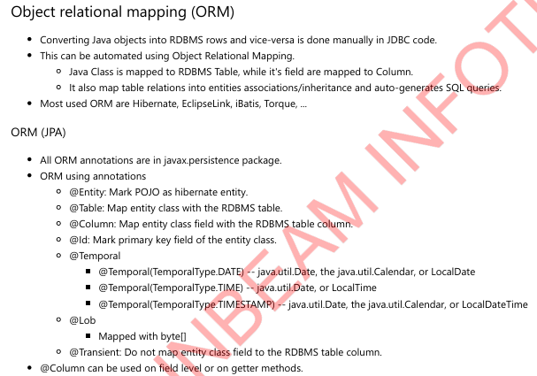

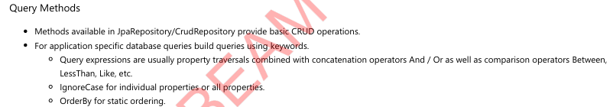

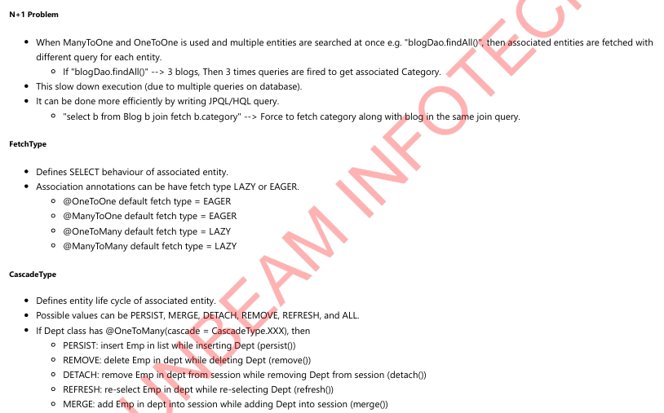

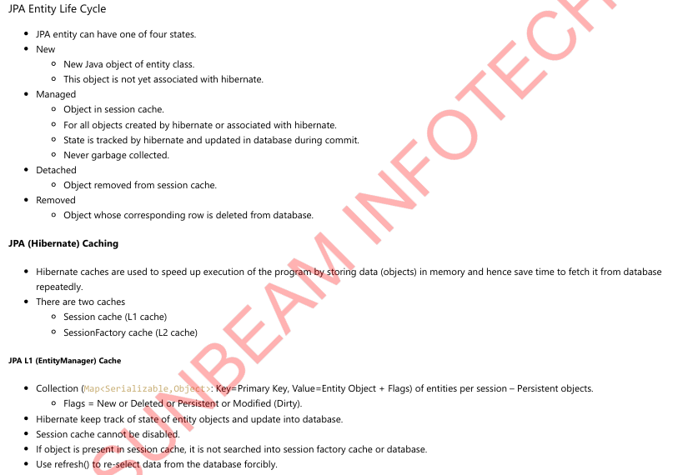

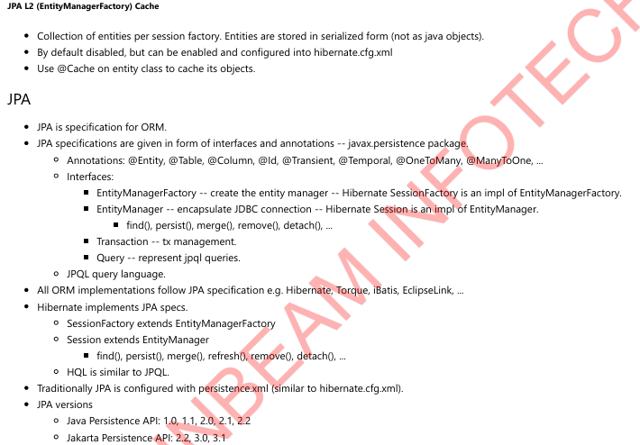

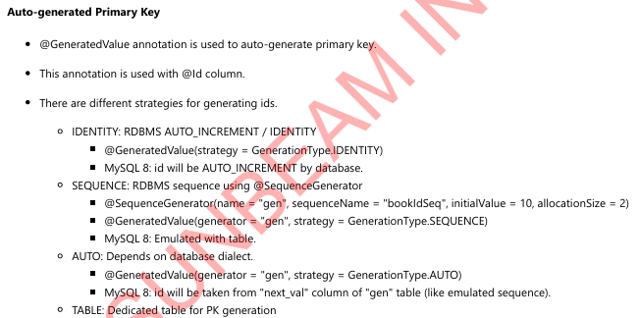



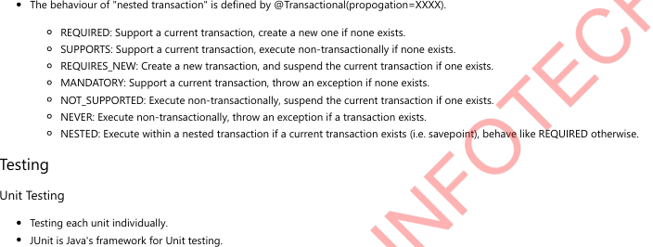

**MCQ:**

**📘 Section 1: Spring Framework (1–20)**

**Q1. Which annotation is used to mark a class as a Spring component?**

**A)** @Bean  
**B)** @Component  
**C)** @Configuration  
**D)** @Service  
**Answer:** B  
**Explanation:** @Component is a generic stereotype for any Spring-managed component.

**Q2. What is the default scope of a Spring bean?**

**A)** Prototype  
**B)** Singleton  
**C)** Request  
**D)** Session  
**Answer:** B  
**Explanation:** By default, Spring beans are singletons.

**Q3. Which interface must a class implement to be aware of its bean name?**

**A)** BeanFactoryAware  
**B)** ApplicationContextAware  
**C)** BeanNameAware  
**D)** BeanDefinitionAware  
**Answer:** C  
**Explanation:** BeanNameAware allows a bean to be aware of its bean name.

**Q4. Which annotation is used to autowire a bean?**

**A)** @Resource  
**B)** @Inject  
**C)** @Autowired  
**D)** @Wire  
**Answer:** C  
**Explanation:** @Autowired is the Spring annotation for automatic dependency injection.

**Q5. Which interface allows you to access the Spring ApplicationContext?**

**A)** ContextAware  
**B)** ApplicationContextAware  
**C)** BeanContextAware  
**D)** EnvironmentAware  
**Answer:** B  
**Explanation:** ApplicationContextAware provides access to the Spring ApplicationContext.

**Q6. What is the function of the @Qualifier annotation in Spring?**

**A)** Disables bean injection  
**B)** Narrows down bean selection when multiple beans match  
**C)** Declares a new bean  
**D)** Overrides bean scope  
**Answer:** B  
**Explanation:** @Qualifier is used with @Autowired to specify which bean to inject.

**Q7. Which lifecycle method is called after a Spring bean is fully initialized?**

**A)** destroy()  
**B)** init()  
**C)** afterPropertiesSet()  
**D)** load()  
**Answer:** C  
**Explanation:** afterPropertiesSet() is called after the properties are set when implementing InitializingBean.

**Q8. What is the correct way to define a bean in a configuration class?**

**A)** @Service  
**B)** @Autowired  
**C)** @Bean  
**D)** @Inject  
**Answer:** C  
**Explanation:** @Bean is used inside @Configuration classes to define beans.

**Q9. What does the @Scope("prototype") annotation mean?**

**A)** Singleton bean  
**B)** A new bean instance is created every time it's requested  
**C)** Request scope for web apps  
**D)** Session-based bean  
**Answer:** B  
**Explanation:** Prototype scope creates a new bean every time it is requested.

**Q10. Which annotation is used to make a class a Spring service component?**

1. @Component
2. @Service  
   **C)** @Repository  
   **D)** @Bean  
   **Answer:** B  
   **Explanation:** @Service is a specialized version of @Component for service classes.

**Q11. What does @PostConstruct do in a Spring bean?**

**A)** Destroys the bean  
**B)** Called after bean creation and dependency injection  
**C)** Initializes the application  
**D)** Creates a singleton instance  
**Answer:** B  
**Explanation:** @PostConstruct is called after the constructor and dependency injection are completed.

**Q12. Which annotation is a specialization of @Component for DAO layers?**

**A)** @Service  
**B)** @Bean  
**C)** @Repository  
**D)** @Qualifier  
**Answer:** C  
**Explanation:** @Repository is a marker for persistence/DAO layers and integrates with exception translation.

**Q13. What does the @Primary annotation do in Spring?**

**A)** Marks the default bean to inject when multiple candidates are present  
**B)** Registers bean first  
**C)** Disables dependency injection  
**D)** Indicates prototype scope  
**Answer:** A  
**Explanation:** @Primary gives a bean precedence when multiple beans of the same type exist.

**Q14. What is ApplicationContext in Spring?**

**A)** Core configuration XML  
**B)** Interface that provides Spring configuration information  
**C)** Wrapper over JDBC  
**D)** Logging framework  
**Answer:** B  
**Explanation:** ApplicationContext provides configuration and manages beans in the Spring container.

**Q15. Which Spring container reads bean definitions from XML files?**

**A)** AnnotationContext  
**B)** BeanFactory  
**C)** ClassPathXmlApplicationContext  
**D)** ContextLoader  
**Answer:** C  
**Explanation:** ClassPathXmlApplicationContext loads context from an XML file on the classpath.

**Q16. What is the purpose of @Configuration in Spring?**

**A)** Enables component scanning  
**B)** Declares a class with bean definitions  
**C)** Loads external libraries  
**D)** Runs the main application  
**Answer:** B  
**Explanation:** @Configuration defines a class with @Bean methods for Spring context.

**Q17. Which of these is NOT a valid bean scope in Spring?**

**A)** Singleton  
**B)** Prototype  
**C)** Session  
**D)** Daemon  
**Answer:** D  
**Explanation:** Daemon is not a Spring bean scope.

**Q18. How are circular dependencies resolved in Spring?**

**A)** Automatically using constructor injection  
**B)** Automatically using setter injection  
**C)** Cannot be resolved  
**D)** By using proxy interfaces  
**Answer:** B  
**Explanation:** Spring can resolve circular dependencies using setter injection.

**Q19. Which interface provides lifecycle callback after bean creation?**

**A)** DisposableBean  
**B)** BeanFactoryAware  
**C)** InitializingBean  
**D)** FactoryBean  
**Answer:** C  
**Explanation:** InitializingBean defines afterPropertiesSet() method called after bean initialization.

**Q20. What is a stereotype annotation in Spring?**

**A)** Used to describe bean scope  
**B)** Meta-annotation for component scanning  
**C)** Used for XML parsing  
**D)** Declares a REST controller  
**Answer:** B  
**Explanation:** Stereotype annotations (@Component, @Service, etc.) mark a class as a Spring-managed component.

**Section 2: Spring Boot (21–40)**

**Q21. What is the main purpose of the @SpringBootApplication annotation?**

**A)** Enable component scanning  
**B)** Enable auto-configuration  
**C)** Mark the main class  
**D)** All of the above

**Answer: D**  
**Explanation:** @SpringBootApplication is a convenience annotation that combines @Configuration, @EnableAutoConfiguration, and @ComponentScan.

**Q22. What file does Spring Boot use for configuration by default?**

**A)** config.yaml  
**B)** application.properties  
**C)** boot.properties  
**D)** settings.xml

**Answer: B**  
**Explanation:** application.properties is the default configuration file in Spring Boot.

**Q23. Which annotation is used to bind properties from application.properties to a Java class?**

**A)** @PropertySource  
**B)** @EnableConfigurationProperties  
**C)** @ConfigurationProperties  
**D)** @Value

**Answer: C**  
**Explanation:** @ConfigurationProperties binds external config properties to Java POJOs.

**Q24. Which embedded server is used by default in Spring Boot?**

**A)** Tomcat  
**B)** Jetty  
**C)** Undertow  
**D)** GlassFish

**Answer: A**  
**Explanation:** Spring Boot uses embedded Tomcat server by default.

**Q25. How do you exclude a specific auto-configuration in Spring Boot?**

**A)** Using excludeAutoConfiguration in @ComponentScan  
**B)** Using @EnableAutoConfiguration  
**C)** Using exclude in @SpringBootApplication  
**D)** Delete the dependency from pom.xml

**Answer: C**  
**Explanation:** You can disable specific auto-configuration classes using exclude attribute in @SpringBootApplication.

**Q26. What is the default port Spring Boot runs on?**

**A)** 80  
**B)** 3000  
**C)** 443  
**D)** 8080

**Answer: D**  
**Explanation:** Spring Boot applications start on port 8080 by default.

**Q27. Where do you define a custom banner in Spring Boot?**

1. banner.html  
   **B)** application.yml  
   **C)** banner.txt  
   **D)** startup.txt **Answer: C**  
   **Explanation:** Place banner.txt in src/main/resources to customize the startup banner.

**Q28. What annotation is used to create a REST controller in Spring Boot?**

**A)** @RestService  
**B)** @RestController  
**C)** @WebController  
**D)** @Api

**Answer: B**  
**Explanation:** @RestController combines @Controller and @ResponseBody.

**Q29. How can you define a custom port in Spring Boot?**

**A)** server.host in application.properties  
**B)** port.host in YAML  
**C)** server.port in application.properties  
**D)** custom.port in application.yaml

**Answer: C**  
**Explanation:** server.port=XXXX in application.properties changes the default port.

**Q30. What does spring.main.web-application-type=none do?**

**A)** Disables all Spring Boot features  
**B)** Enables web application only  
**C)** Disables web environment  
**D)** Enables only servlet context

**Answer: C**  
**Explanation:** This disables the web environment and is used for CLI/non-web apps.

**Q31. Which starter is used for building web applications?**

**A)** spring-boot-starter  
**B)** spring-boot-starter-data  
**C)** spring-boot-starter-web  
**D)** spring-boot-starter-core

**Answer: C**  
**Explanation:** spring-boot-starter-web includes Tomcat, Spring MVC, and Jackson.

**Q32. How do you enable caching in Spring Boot?**

**A)** @EnableCache  
**B)** @EnableCaching  
**C)** @SpringBootCaching  
**D)** @CacheEnable

**Answer: B**  
**Explanation:** Use @EnableCaching to enable Spring’s annotation-driven cache management.

**Q33. Which property sets logging level in application.properties?**

**A)** logging.status  
**B)** debug.level  
**C)** log.level.root  
**D)** logging.level.root

**Answer: D**  
**Explanation:** Use logging.level.root=INFO to configure logging.

**Q34. Which annotation is used for scheduled tasks in Spring Boot?**

**A)** @Timer  
**B)** @EnableScheduling  
**C)** @ScheduledTask  
**D)** @RunScheduled

**Answer: B**  
**Explanation:** @EnableScheduling allows scheduling support.

**Q35. How do you define a scheduled method in Spring Boot?**

**A)** @EnableScheduler  
**B)** @Run  
**C)** @Scheduled  
**D)** @Execute

**Answer: C**  
**Explanation:** @Scheduled is used to define scheduled tasks.

**Q36. What is the use of CommandLineRunner interface?**

**A)** Custom REST configuration  
**B)** To load data at startup  
**C)** To enable security  
**D)** To schedule tasks

**Answer: B**  
**Explanation:** CommandLineRunner.run() executes after application context is loaded.

**Q37. What’s the file name to configure YAML in Spring Boot?**

**A)** boot.yaml  
**B)** config.yaml  
**C)** application.yaml  
**D)** settings.yml

**Answer: C**  
**Explanation:** application.yaml is the YAML-based config file.

**Q38. What’s the use of @SpringBootTest?**

**A)** Starts a full application context for testing  
**B)** Disables testing  
**C)** Only enables JPA tests  
**D)** Tests only beans

**Answer: A**  
**Explanation:** @SpringBootTest loads full Spring context for integration testing.

**Q39. What is the purpose of spring-boot-devtools?**

**A)** Database access  
**B)** Hot reload, auto restart  
**C)** Production deployment  
**D)** Logging

**Answer: B**  
**Explanation:** spring-boot-devtools enables hot reloading during development.

**Q40. Where should application.properties be placed?**

**A)** src/test/java  
**B)** root directory  
**C)** src/main/resources  
**D)** META-INF

**Answer: C**  
**Explanation:** application.properties must be placed in src/main/resources.

**Section 3: JDBC (41–60)**

**Q41. Which class is used to execute a SQL query in plain JDBC?**

**A)** Connection  
**B)** Statement  
**C)** ResultSet  
**D)** DriverManager

**Answer: B**  
**Explanation:** The Statement object is used to execute SQL queries.

**Q42. What is the method used to load a JDBC driver?**

**A)** Driver.load()  
**B)** Class.forName()  
**C)** DriverManager.getDriver()  
**D)** Connection.loadDriver()

**Answer: B**  
**Explanation:** Class.forName() loads the JDBC driver class.

**Q43. Which interface provides methods for committing or rolling back a transaction?**

**A)** Statement  
**B)** PreparedStatement  
**C)** Connection  
**D)** DriverManager

**Answer: C**  
**Explanation:** The Connection interface allows committing or rolling back transactions.

**Q44. What is the correct way to prevent SQL injection in JDBC?**

**A)** Use raw queries  
**B)** Use Statement  
**C)** Use PreparedStatement  
**D)** Escape user input manually

**Answer: C**  
**Explanation:** PreparedStatement avoids SQL injection by safely setting parameters.

**Q45. Which method is used to retrieve data from a ResultSet?**

**A)** execute()  
**B)** getData()  
**C)** next()  
**D)** fetch()

**Answer: C**  
**Explanation:** next() moves the cursor to the next row and returns true if there is a row.

**Q46. What is returned by executeQuery() method of Statement?**

**A)** int  
**B)** ResultSet  
**C)** Boolean  
**D)** void

**Answer: B**  
**Explanation:** executeQuery() returns a ResultSet object containing the query results.

**Q47. What does setAutoCommit(false) do?**

**A)** Begins a new transaction  
**B)** Commits automatically after every query  
**C)** Disables auto-commit, enabling manual control over commits  
**D)** Rolls back automatically

**Answer: C**  
**Explanation:** Disabling auto-commit lets you manually manage transactions.

**Q48. Which method is used to roll back a transaction in JDBC?**

**A)** rollback() on Statement  
**B)** rollback() on ResultSet  
**C)** rollback() on Connection  
**D)** rollback() on DriverManager

**Answer: C**  
**Explanation:** The Connection object provides the rollback() method.

**Q49. What does close() do on Connection, Statement, or ResultSet?**

**A)** Commits the transaction  
**B)** Cleans resources  
**C)** Kills the database  
**D)** Deletes the schema

**Answer: B**  
**Explanation:** close() releases resources held by the JDBC object.

**Q50. Which method is used to create a PreparedStatement?**

**A)** createStatement()  
**B)** prepareStatement()  
**C)** executeStatement()  
**D)** initStatement()

**Answer: B**  
**Explanation:** prepareStatement() creates a PreparedStatement object.

**Q51. How can you prevent resource leaks in JDBC?**

**A)** Ignore close() calls  
**B)** Use finally block to close connections  
**C)** Let JVM handle it  
**D)** Only use one connection always

**Answer: B**  
**Explanation:** Resources should be closed in a finally block or using try-with-resources.

**Q52. How do you set a String parameter in a PreparedStatement?**

**A)** setParameter(1, value)  
**B)** setString(1, value)  
**C)** put(1, value)  
**D)** assign(1, value)

**Answer: B**  
**Explanation:** Use setString(index, value) for string parameters.

**Q53. What is the JDBC URL format for MySQL?**

**A)** jdbc:mysql://host:port/db  
**B)** jdbc:sql:mysql/host  
**C)** jdbc:mysql:db@host  
**D)** sql:mysql::db//host

**Answer: A**  
**Explanation:** MySQL JDBC URL follows the format: jdbc:mysql://host:port/dbname.

**Q54. What class is used to load JDBC drivers explicitly?**

**A)** DriverLoader  
**B)** DriverManager  
**C)** ClassLoader  
**D)** Class.forName()

**Answer: D**  
**Explanation:** Class.forName("com.mysql.jdbc.Driver") loads the driver.

**Q55. Which of the following is not a valid method on the ResultSet object?**

**A)** getString()  
**B)** getInt()  
**C)** next()  
**D)** execute()

**Answer: D**  
**Explanation:** execute() is a method on Statement, not ResultSet.

**Q56. How do you update a record using JDBC?**

**A)** executeUpdate("UPDATE ...")  
**B)** update()  
**C)** execute()  
**D)** getUpdate()

**Answer: A**  
**Explanation:** executeUpdate() is used for DML operations like UPDATE.

**Q57. What does executeUpdate() return?**

**A)** Boolean  
**B)** String  
**C)** Number of affected rows  
**D)** ResultSet

**Answer: C**  
**Explanation:** It returns the number of rows affected by the operation.

**Q58. Which class is responsible for registering the JDBC driver?**

**A)** DriverManager  
**B)** Connection  
**C)** ResultSet  
**D)** SQLException

**Answer: A**  
**Explanation:** DriverManager handles JDBC driver registration.

**Q59. What is the role of SQLException in JDBC?**

**A)** Indicates a successful operation  
**B)** Used for logging  
**C)** Handles SQL errors  
**D)** Loads SQL schema

**Answer: C**  
**Explanation:** SQLException handles errors that occur while interacting with the database.

**Q60. Which method is used to open a database connection in JDBC?**

**A)** getConnection() on DriverManager  
**B)** connect() on Connection  
**C)** open() on Driver  
**D)** access() on Statement

**Answer: A**  
**Explanation:** DriverManager.getConnection() is used to open a connection.

**Section 4: JPA (61–80)**

**Q61. Which annotation is used to map a class as a JPA entity?**

**A)** @Model  
**B)** @POJO  
**C)** @Entity  
**D)** @JPAObject

**Answer: C**  
**Explanation:** @Entity marks a class as a JPA entity.

**Q62. Which annotation is used to specify the primary key in a JPA entity?**

**A)** @PK  
**B)** @Id  
**C)** @Key  
**D)** @Primary

**Answer: B**  
**Explanation:** @Id defines the primary key of a JPA entity.

**Q63. Which annotation defines a column in a JPA entity?**

**A)** @Field  
**B)** @Column  
**C)** @Attribute  
**D)** @DataField

**Answer: B**  
**Explanation:** @Column is used to map an entity field to a table column.

**Q64. Which annotation specifies a table name for an entity?**

**A)** @Entity  
**B)** @Table  
**C)** @JoinTable  
**D)** @Database

**Answer: B**  
**Explanation:** @Table(name="...") specifies the table name.

**Q65. Which strategy is NOT valid for ID generation in JPA?**

**A)** GenerationType.AUTO  
**B)** GenerationType.IDENTITY  
**C)** GenerationType.SEQUENCE  
**D)** GenerationType.UUID

**Answer: D**  
**Explanation:** GenerationType.UUID is not a standard strategy.

**Q66. What does the @GeneratedValue annotation do?**

**A)** Encrypts the ID  
**B)** Marks a primary key as auto-generated  
**C)** Declares a relationship  
**D)** Overrides column type

**Answer: B**  
**Explanation:** @GeneratedValue lets JPA automatically generate primary key values.

**Q67. Which annotation is used to define a many-to-one relationship?**

**A)** @JoinColumn  
**B)** @ManyToOne  
**C)** @OneToMany  
**D)** @ManyToMany

**Answer: B**  
**Explanation:** @ManyToOne establishes a many-to-one relationship.

**Q68. What is the default fetch type for @ManyToOne?**

**A)** LAZY  
**B)** EAGER  
**C)** DEFAULT  
**D)** NONE

**Answer: B**  
**Explanation:** @ManyToOne is EAGER by default.

**Q69. Which annotation is used to define a one-to-many relationship?**

**A)** @OneToMany  
**B)** @JoinTable  
**C)** @ManyToOne  
**D)** @Collection

**Answer: A**  
**Explanation:** @OneToMany maps a one-to-many association.

**Q70. Which attribute is used to map the owning side in @OneToMany?**

**A)** name  
**B)** targetEntity  
**C)** mappedBy  
**D)** joinBy

**Answer: C**  
**Explanation:** mappedBy defines the inverse side of the relationship.

**Q71. Which annotation defines the foreign key column for a relationship?**

**A)** @ForeignKey  
**B)** @Relation  
**C)** @JoinColumn  
**D)** @Link

**Answer: C**  
**Explanation:** @JoinColumn maps a foreign key column.

**Q72. What is the use of @Transient in JPA?**

**A)** Declares a derived column  
**B)** Ignores the field from persistence  
**C)** Declares a primary key  
**D)** Used for caching

**Answer: B**  
**Explanation:** Fields annotated with @Transient are not persisted.

**Q73. What is the correct method to persist an entity using EntityManager?**

**A)** save()  
**B)** insert()  
**C)** persist()  
**D)** merge()

**Answer: C**  
**Explanation:** persist() stores a new entity instance in the database.

**Q74. Which method updates a detached entity?**

**A)** persist()  
**B)** update()  
**C)** merge()  
**D)** attach()

**Answer: C**  
**Explanation:** merge() updates the database with a detached entity.

**Q75. Which method removes an entity from the persistence context?**

**A)** remove()  
**B)** delete()  
**C)** destroy()  
**D)** terminate()

**Answer: A**  
**Explanation:** remove() deletes the entity from the database.

**Q76. Which annotation is used for defining a named query?**

**A)** @NamedQuery  
**B)** @QueryName  
**C)** @StaticQuery  
**D)** @JPQL

**Answer: A**  
**Explanation:** @NamedQuery defines static queries.

**Q77. Which annotation allows use of JPQL in Spring Data JPA?**

**A)** @Query  
**B)** @JPQL  
**C)** @Script  
**D)** @SQL

**Answer: A**  
**Explanation:** @Query lets you define custom JPQL or native SQL queries.

**Q78. What does CascadeType.ALL mean in JPA?**

**A)** Cascade only persist  
**B)** Cascade only delete  
**C)** Apply all cascade operations (persist, merge, remove, etc.)  
**D)** No cascading

**Answer: C**  
**Explanation:** CascadeType.ALL applies all lifecycle operations to child entities.

**Q79. What is the role of the EntityManager interface?**

**A)** Configure Spring Boot  
**B)** Persist and manage entity lifecycle  
**C)** Manage JDBC connections  
**D)** Generate DDL

**Answer: B**  
**Explanation:** EntityManager handles all CRUD operations and entity state transitions.

**Q80. What does fetch = FetchType.LAZY do?**

**A)** Loads all entities eagerly  
**B)** Skips loading  
**C)** Delays loading until property is accessed  
**D)** Caches query

**Answer: C**  
**Explanation:** LAZY loading delays the fetching of associated data until needed.

**Section 5: Hibernate (81–100)**

**Q81. What is the file name used for Hibernate configuration?**

**A)** hibernate-config.xml  
**B)** hibernate.properties  
**C)** hibernate.cfg.xml  
**D)** config.xml

**Answer: C**  
**Explanation:** hibernate.cfg.xml is the default configuration file in Hibernate.

**Q82. Which Hibernate interface is used to interact with the database?**

**A)** SessionFactory  
**B)** Transaction  
**C)** Session  
**D)** EntityManager

**Answer: C**  
**Explanation:** Session interface is used to perform CRUD operations in Hibernate.

**Q83. Which method saves an entity in Hibernate?**

**A)** store()  
**B)** save()  
**C)** create()  
**D)** insert()

**Answer: B**  
**Explanation:** save() method persists a new entity into the database.

**Q84. What is the use of SessionFactory in Hibernate?**

**A)** Manage sessions and cache metadata  
**B)** Execute SQL queries  
**C)** Store configuration  
**D)** Map tables to objects

**Answer: A**  
**Explanation:** SessionFactory is a factory for Session and caches metadata.

**Q85. Which object is responsible for transaction management in Hibernate?**

**A)** Session  
**B)** EntityManager  
**C)** Transaction  
**D)** HibernateContext

**Answer: C**  
**Explanation:** Transaction handles commit and rollback operations.

**Q86. What is the default cache level used in Hibernate?**

**A)** First-level  
**B)** Second-level  
**C)** Query cache  
**D)** No cache

**Answer: A**  
**Explanation:** Hibernate uses first-level cache by default for each session.

**Q87. Which method is used to retrieve an entity by its ID?**

**A)** load()  
**B)** getById()  
**C)** find()  
**D)** get()

**Answer: D**  
**Explanation:** get() retrieves an entity by ID and returns null if not found.

**Q88. What does load() method do differently than get()?**

**A)** Executes immediately  
**B)** Returns null if not found  
**C)** Returns proxy and loads lazily  
**D)** Bypasses session cache

**Answer: C**  
**Explanation:** load() returns a proxy and throws an exception if not found.

**Q89. How do you map one-to-one relationships in Hibernate?**

**A)** @OneToOne  
**B)** @OneToMany  
**C)** @JoinColumn  
**D)** @EntityLink

**Answer: A**  
**Explanation:** @OneToOne defines a one-to-one mapping.

**Q90. Which annotation enables second-level caching in Hibernate?**

**A)** @EnableCaching  
**B)** @Cache  
**C)** @HibernateCache  
**D)** @SecondLevelCache

**Answer: B**  
**Explanation:** @Cache enables second-level cache configuration.

**Q91. What is the purpose of hibernate.hbm2ddl.auto property?**

**A)** Define the database name  
**B)** Set dialect  
**C)** Auto generate schema  
**D)** Enable caching

**Answer: C**  
**Explanation:** hibernate.hbm2ddl.auto defines how schema is managed (create, update, validate, none).

**Q92. What is the purpose of Hibernate Dialect?**

**A)** Translate Java to SQL  
**B)** Specify database-specific SQL syntax  
**C)** Configure JPA mappings  
**D)** Setup connection pool

**Answer: B**  
**Explanation:** Dialect tells Hibernate how to generate SQL for the specific DB.

**Q93. Which class manages the Hibernate lifecycle?**

**A)** HibernateUtil  
**B)** SessionFactory  
**C)** Session  
**D)** HibernateContext

**Answer: B**  
**Explanation:** SessionFactory is responsible for lifecycle and configuration.

**Q94. What does the merge() method do in Hibernate?**

**A)** Deletes the record  
**B)** Merges changes of a detached object into the persistence context  
**C)** Validates a transaction  
**D)** Flushes the cache

**Answer: B**  
**Explanation:** merge() reattaches and synchronizes changes of a detached entity.

**Q95. What happens when you call flush() in Hibernate?**

**A)** Commits the transaction  
**B)** Refreshes the UI  
**C)** Synchronizes session state with DB  
**D)** Deletes cached entities

**Answer: C**  
**Explanation:** flush() pushes changes from session to the database.

**Q96. How can you map an inheritance hierarchy in Hibernate?**

**A)** Using @Inheritance annotation  
**B)** @Polymorphic annotation  
**C)** @Extend annotation  
**D)** @Supertype annotation

**Answer: A**  
**Explanation:** @Inheritance is used for entity inheritance mapping.

**Q97. Which strategy is NOT valid for Hibernate inheritance?**

**A)** SINGLE_TABLE  
**B)** TABLE_PER_CLASS  
**C)** JOINED  
**D)** SPLIT

**Answer: D**  
**Explanation:** SPLIT is not a valid inheritance strategy in Hibernate.

**Q98. What is the default inheritance strategy in Hibernate?**

**A)** JOINED  
**B)** TABLE_PER_CLASS  
**C)** SINGLE_TABLE  
**D)** NONE

**Answer: C**  
**Explanation:** SINGLE_TABLE is the default strategy.

**Q99. What is @DiscriminatorColumn used for?**

**A)** Defines cache strategy  
**B)** Specifies table for joined inheritance  
**C)** Defines column used to distinguish subclasses  
**D)** Configures fetch strategy

**Answer: C**  
**Explanation:** @DiscriminatorColumn helps identify which subclass the row belongs to.

**Q100. What is the difference between save() and persist() in Hibernate?**

**A)** persist () returns ID, save () doesn’t  
**B)** persist () works outside transactions  
**C)** save() returns ID; persist() returns void  
**D)** No difference

**Answer: C**  
**Explanation:** save() returns generated ID; persist() returns void and is JPA-compliant.

**Section 6: REST API (101–130)**

**Q101. What does REST stand for?**

**A)** Representational Stateless Transfer  
**B)** Remote Execution Service Transfer  
**C)** Representational State Transfer  
**D)** Request Encoding Syntax Transfer

**Answer: C**  
**Explanation:** REST stands for Representational State Transfer, an architectural style for APIs.

**Q102. Which HTTP method is idempotent?**

**A)** POST  
**B)** GET  
**C)** PATCH  
**D)** PUT

**Answer: D**  
**Explanation:** PUT is idempotent because making the same call multiple times will not change the result beyond the first request.

**Q103. Which status code represents a successful DELETE request?**

**A)** 200  
**B)** 201  
**C)** 204  
**D)** 404

**Answer: C**  
**Explanation:** 204 No Content is usually returned for successful DELETE without a response body.

**Q104. What is the correct annotation in Spring to handle a GET request?**

**A)** @RequestHandler  
**B)** @Get  
**C)** @GetMapping  
**D)** @Fetch

**Answer: C**  
**Explanation:** @GetMapping is the specific shortcut for handling GET requests.

**Q105. Which annotation maps path variables in Spring Boot REST?**

**A)** @RequestParam  
**B)** @PathParam  
**C)** @PathVariable  
**D)** @Route

**Answer: C**  
**Explanation:** @PathVariable maps URI template variables to method parameters.

**Q106. Which HTTP status code indicates a resource was created?**

**A)** 200  
**B)** 204  
**C)** 302  
**D)** 201

**Answer: D**  
**Explanation:** 201 Created indicates a resource has been successfully created.

**Q107. What does @RequestBody do in Spring MVC?**

**A)** Parses path params  
**B)** Binds the request body to a method parameter  
**C)** Retrieves headers  
**D)** Injects beans

**Answer: B**  
**Explanation:** @RequestBody maps the entire request body to a method argument.

**Q108. Which library is commonly used for JSON conversion in Spring Boot?**

**A)** Gson  
**B)** Jackson  
**C)** FastJson  
**D)** JSONSimple

**Answer: B**  
**Explanation:** Spring Boot uses Jackson by default for JSON serialization/deserialization.

**Q109. What annotation is used for global exception handling in Spring REST?**

**A)** @ControllerAdvice  
**B)** @RestController  
**C)** @ExceptionMapper  
**D)** @ErrorHandler

**Answer: A**  
**Explanation:** @ControllerAdvice handles exceptions across the whole application.

**Q110. What annotation marks a class as a REST controller in Spring Boot?**

**A)** @RestApi  
**B)** @RestController  
**C)** @Controller  
**D)** @ApiController

**Answer: B**  
**Explanation:** @RestController combines @Controller and @ResponseBody.

**Q111. Which HTTP method is not safe?**

**A)** GET  
**B)** PUT  
**C)** HEAD  
**D)** OPTIONS

**Answer: B**  
**Explanation:** PUT modifies state and is therefore not a safe method.

**Q112. What does @ResponseStatus do?**

**A)** Defines a default view  
**B)** Binds status code to an exception or method  
**C)** Logs the request  
**D)** Maps HTTP method

**Answer: B**  
**Explanation:** @ResponseStatus binds an HTTP status to a method or exception class.

**Q113. Which tool is commonly used to document REST APIs?**

**A)** Maven  
**B)** Swagger  
**C)** Jenkins  
**D)** Prometheus

**Answer: B**  
**Explanation:** Swagger (now OpenAPI) provides API documentation and testing.

**Q114. What does HATEOAS add to REST APIs?**

**A)** Authentication  
**B)** Versioning  
**C)** Hypermedia links  
**D)** Rate limiting

**Answer: C**  
**Explanation:** HATEOAS adds hypermedia links to API responses.

**Q115. What is the default response content type in Spring Boot?**

**A)** text/plain  
**B)** application/json  
**C)** application/xml  
**D)** application/x-www-form-urlencoded

**Answer: B**  
**Explanation:** JSON is the default content type in Spring Boot.

**Q116. What is the correct status code for unauthorized access?**

**A)** 403  
**B)** 500  
**C)** 401  
**D)** 404

**Answer: C**  
**Explanation:** 401 Unauthorized indicates authentication is required.

**Q117. Which annotation binds a request parameter to a method argument?**

**A)** @PathVariable  
**B)** @RequestParam  
**C)** @Param  
**D)** @QueryParam

**Answer: B**  
**Explanation:** @RequestParam maps query parameters to method arguments.

**Q118. What is the purpose of @CrossOrigin?**

**A)** Enables URL shortening  
**B)** Allows cross-origin requests  
**C)** Converts XML to JSON  
**D)** Adds cache headers

**Answer: B**  
**Explanation:** @CrossOrigin enables CORS (Cross-Origin Resource Sharing).

**Q119. What is the standard port for REST APIs over HTTPS?**

**A)** 80  
**B)** 443  
**C)** 22  
**D)** 8443

**Answer: B**  
**Explanation:** 443 is the default port for HTTPS.

**Q120. What does OPTIONS method do?**

**A)** Sends request data  
**B)** Gets resource metadata  
**C)** Deletes a resource  
**D)** Updates a resource

**Answer: B**  
**Explanation:** OPTIONS returns allowed methods and headers for a resource.

**Q121. Which HTTP method is used to partially update a resource?**

**A)** PUT  
**B)** PATCH  
**C)** POST  
**D)** UPDATE  
**✅ Answer: B**  
**Explanation:** PATCH is used to apply partial updates to a resource.

**Q122. What is the use of @RequestHeader in Spring?**

**A)** Access path variables  
**B)** Access query parameters  
**C)** Access request headers  
**D)** Add CORS policy  
**✅ Answer: C**  
**Explanation:** @RequestHeader binds method parameters to request header values.

**Q123. What is the role of HttpEntity in Spring?**

**A)** Perform async call  
**B)** Carry request and response metadata and body  
**C)** Auto log requests  
**D)** Configure SSL  
**✅ Answer: B**  
**Explanation:** HttpEntity encapsulates headers and body of an HTTP request or response.

**Q124. What does produces attribute do in @RequestMapping?**

**A)** Sets return type of method  
**B)** Specifies MIME type of response  
**C)** Sets input data format  
**D)** Defines path parameters  
**✅ Answer: B**  
**Explanation:** produces tells Spring the content type to be produced in response.

**Q125. What does consume attribute in @PostMapping define?**

**A)** What HTTP verbs are accepted  
**B)** The expected request content type  
**C)** What fields to map  
**D)** Which controller handles it  
**✅ Answer: B**  
**Explanation:** consumes defines the MIME type the method can handle in the request body.

**Q126. What does ResponseEntity return?**

**A)** Only body  
**B)** Only headers  
**C)** Body and HTTP status code  
**D)** Path parameters  
**✅ Answer: C**  
**Explanation:** ResponseEntity represents a complete HTTP response, including headers, body, and status.

**Q127. What’s the HTTP status code for “Forbidden”?**

**A)** 401  
**B)** 403  
**C)** 404  
**D)** 500  
**✅ Answer: B**  
**Explanation:** 403 Forbidden indicates the server understood the request but refuses to authorize it.

**Q128. What is the default path for actuator health endpoint in Spring Boot?**

**A)** /check  
**B)** /status  
**C)** /health  
**D)** /monitor  
**✅ Answer: C**  
**Explanation:** /actuator/health is the default health-check endpoint.

**Q129. What does the @DeleteMapping annotation do?**

**A)** Deletes a Spring bean  
**B)** Maps HTTP DELETE requests to a method  
**C)** Deletes a file  
**D)** Denotes security mapping  
**✅ Answer: B**  
**Explanation:** @DeleteMapping is used to map DELETE requests in Spring MVC.

**Q130. How do you specify multiple request mappings to a method?**

**A)** Use multiple @RequestMapping annotations  
**B)** Use array in @RequestMapping(value={...})  
**C)** Declare in application.properties  
**D)** Not possible  
**✅ Answer: B**  
**Explanation:** You can map multiple URLs using an array in @RequestMapping(value={"/a", "/b"}).